Introduction Letter

Hello Empowered Leaders!

My name is FIRST LAST and I’m your Local Chapter President of JCI (Chapter Name).

Now write in a personalized letter that is exciting and motivating to clearly and concisely get members to understand your area and achieve success by engaging members in your area of focus. Make it one page, make it personal. Have fun with it!

FIRST LAST
Title
Chapter Name, State
JCI USA

JCI Local Plan of Action

JCI Mission
To provide development opportunities that empower young people to create positive change.

JCI Vision
To be the leading global network of young active citizens.

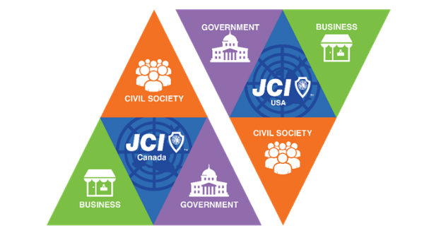
JCI’s Core Philosophy is to:
Inspire confidence,
Unite communities,
Enhance equal opportunities,
Establish justice,
Embrace cultural diversity, and
Create sustainable impact.

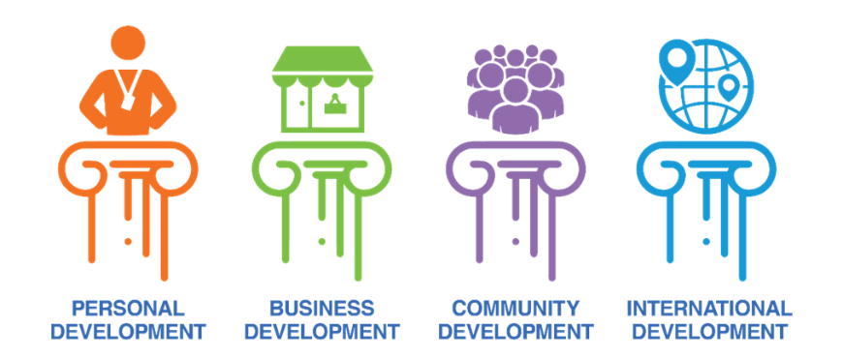
Four Pillars of Development
- Business
- Individual
- Community
- International

Key Areas of Development
- Collaborate
- Motivate
- Impact
- Connect
- Invest

Local Board Member Roster
Position | Name | Email/Phone | Responsibilities

JCI will focus the power of young people to advance sustainable impact.
Key Objectives:

Strategy | Action Steps | Who is Responsible | Timeline & Desired Budget

JCI will unite the passion of young people to motivate bold action.
Key Objectives:

Strategy | Action Steps |  | Who is Responsible |  | Timeline & Budget

JCI will accelerate transformation by investing in technological,

financial and human resources.
Key Objectives:

Strategy |  | Action Steps |  | Who is Responsible |  | Timeline & Budget

JCI will foster a collaborative culture in a dynamic world.
Key Objectives:

Strategy | Action Steps | Who is Responsible | Timeline & Budget

International Development

JCI will connect young people to drive JCI USA in a positive direction.
Key Objectives:

Strategy | Action Steps | Who is Responsible | Timeline & Budget

January | February | March | April
May | June | July | August
September | October | November | December

January | February | March | April
May | June | July | August
September | October | November | December

2020 Schedule of Events

